Given an array nums of 0s and 1s and an integer k, return True if all 1's are at least k places away from each other, otherwise return False.

**Example 1:**

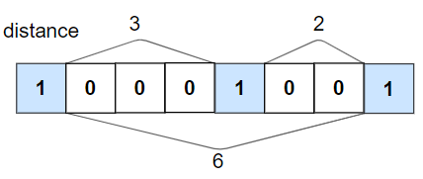

**Input:** nums = [1,0,0,0,1,0,0,1], k = 2

**Output:** true

**Explanation:** Each of the 1s are at least 2 places away from each other.

**Example 2:**

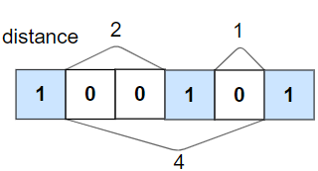

**Input:** nums = [1,0,0,1,0,1], k = 2

**Output:** false

**Explanation:** The second 1 and third 1 are only one apart from each other.

**Example 3:**

**Input:** nums = [1,1,1,1,1], k = 0

**Output:** true

**Example 4:**

**Input:** nums = [0,1,0,1], k = 1

**Output:** true

**Constraints:**

* 1 <= nums.length <= 10^5
* 0 <= k <= nums.length
* nums[i] is 0 or 1